Group Presentation
Radioactivity – Good or Bad?
Due:
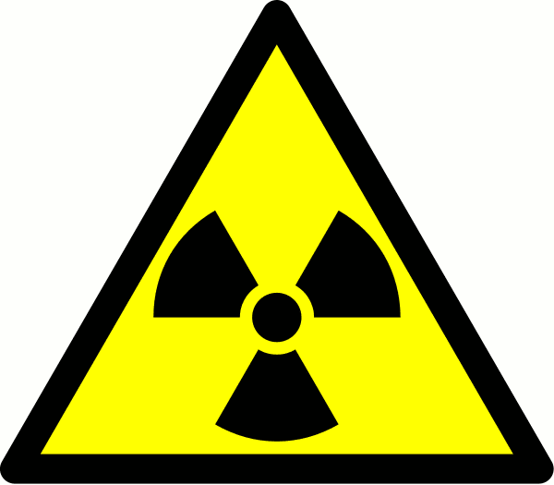

Radiation surrounds us naturally from the sun to some types of rocks.
Our body cells are designed to repair some radiation damage. However, nuclear radiation can damage or destroy living cells, stop vital organs in the body working properly, and cause cancer.

The stronger the radiation, and the longer the exposure time, the greater the risk.

Your Task:

- Choose 1 use of nuclear technology (some ideas listed below), discuss facts and information about them as a group.
- Introduce the topic – focus on importance to society etc.
- Discuss ADVANTAGES and DISADVANTAGES of these technologies.
- Summarise your ideas about your chosen topic as a concise document.
- Include a detailed and varied Bibliography.

Your presentation will be 5 min per group (max. 4 /group). Accompanied by 2 pages of individual notes.

Ideas to Research
Generation of Nuclear Power
Radiotherapy and other medical applications
Carbon Dating
Irradiation of Food
Smoke Detectors
Checking welds in underground pipes
Nuclear weapons

+ more issues that interest you (ask for teachers permission)

